E-Commerce Order Analytics System
Project Implementation & Execution Report

Step 1: Mock Data Generation
We run 'generate_data.py' to generate raw customer, product, order, and order item CSV files with simulated data anomalies.
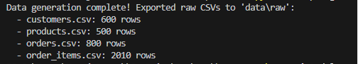

Step 2: Programmatic Data Cleaning
We clean the raw CSV files using Pandas, standardizing formats, and validating relational constraints.
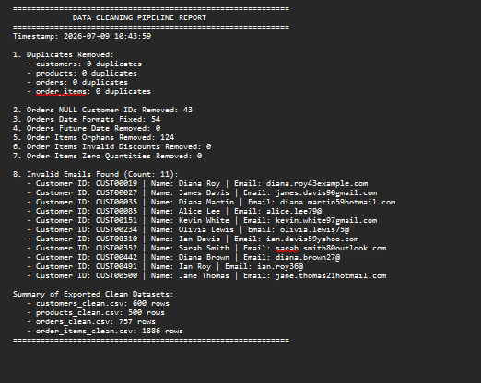

Step 3: Edge Case Testing and Ingestion
We verify validation rules using unit tests, deploy the database schema in SQLite, and import the cleaned datasets.
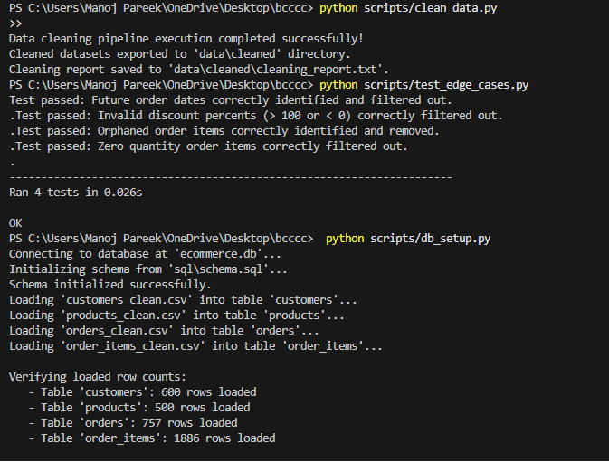

Step 4: Execute SQL Aggregations & Joins
We run basic and intermediate SQL queries to analyze category revenues, top customers, order volumes, and return rates.
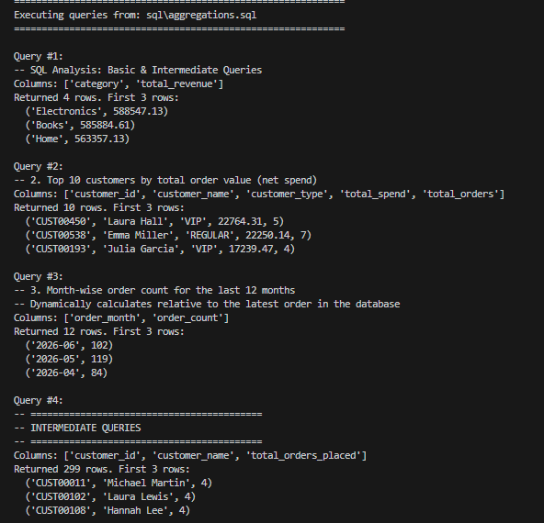

Step 5: Execute SQL Window Functions & CTEs
We run advanced SQL window functions and multi-level CTEs to analyze product rankings, spend gaps, and cohort metrics.
